**International Islamic University Islamabad**

**Faculty of Engineering and Technology**

**Department of Electrical & Computer Engineering**



C++ Project Report

# Project Title

Library Management System

# Team Members

Name Roles

* Ahsan Naaz(Team Leader) Admin Menu and all admin function
* Ameer Hamza Search functions for library books
* Ahmad Student Menu and Student Menu functions
* Pir Zada Majid Password, Code Testing, small functions(clear,

count, count status function)

* Raja Muhammad Anees Idea, Code testing and Guest menu making

# 3. Project Goals / Objectives

* Allow Admin to easly enter and delete books in Libarary
* Track the History of all books
* Display all Issued and Avaliable books
* Sort and Display Books in Library
* Easly search books by their ID , Author name, Title
* Allow Admin , Student and Guest to view and borrow books easly

# 4. Problem Statement

The real-world problem is being solved with library management system as it involves Bookkeeping ,Borrowing ,Returning ,Searching features. Allows Admin Students and Guest to easly take book form Library and Track the history of all borrowed and available books

# 5. Tools and Languages Used

**Languages**

C++

**Tools**

Dev-C++ 5.0(4.9.9.2) with Mingw compiler and GDB 5.2.1 debugger

Visual studio 2022

# 6. Functional Requirements

Admin features:

* Password
* Add Book
* Delete Book
* Update Book
* View Books
* Clear Books
* Count Books
* Count Status
* Search By ID

Student features:

* Password
* View Book
* Search By Title
* Search By Author
* Borrow Book
* Return Book
* View Borrowed
* Student features:

Guest features:

* View Book
* Search By Title

# 7. Algorithm Design / Logic Description

main()

mainMenu() AlreadyBooks()

adminMenu() StudentMenu() guestMenu()

addBook deleteBook updateBook clearBooks countBooks countStatus sortBooks searchByID

viewBooks borrowBook returnBook viewBorrowed searchByTitle searchByAuthor

viewBooks

searchByTitle

# 8. Function List and Descriptions

* void AlreadyBooks();
* void addBook();
* void deleteBook();
* void updateBook();
* void viewBooks();
* void clearBooks();
* void countBooks();
* void countStatus();
* void sortBooks();
* void searchByID();
* void searchByTitle();
* void searchByAuthor();
* void borrowBook();
* void returnBook();
* void viewBorrowed();
* void adminMenu();
* void StudentMenu();
* void guestMenu();
* void mainMenu();

# 9. Screenshots or Sample I/O

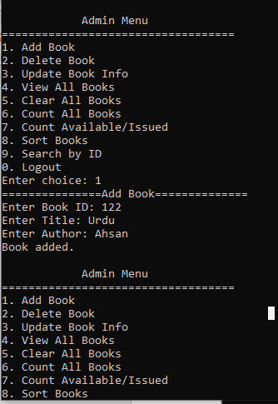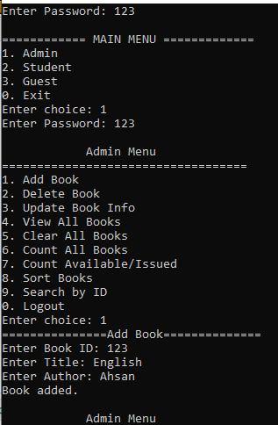

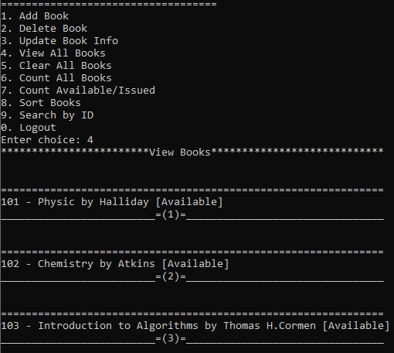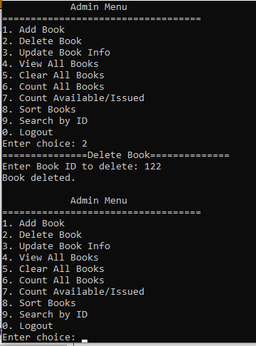

# 11. Challenges Faced

**Designing Database :**

Challege is face in storing books .Author of books, title of books and isIssued(true/false) are different date type Using list this issue is not solved structure is used.

**SortBooks:**

Making sortBooks function challenge is face.

**Error in int ID:**

Using int id error is faced it is changed with string date type and error is solved

# 12. Conclusion / Future Improvements

**Conclusion:**

This Library management system has make the library system to manage easily allow admin Student and Guest to get library books easily and track their history.

**Future Improvements**

* Implement of Graphic user Interface
* More used books on top of list
* Accounts system for admin and user
* Allow admin to delete accounts of Student
* Wishlist of books for Student
* Update account information by user and admin
* Number of users and Admins are allowed
* Help to choose books